**PROJECT**

**DOCUMENTATION**

Estimation of business expenses

INTRODUCTION

Overview: This report deal's into the fascinating realm of business expenses and provides a visual exploration of the various expenditures incurred by different businesses. It showcases the distribution of expenses, identifies key cost drivers, and highlights areas of potential optimization or concern. The visual representations allow for intuitive analysis, facilitating a deeper understanding of expenditure patterns and their implications for business performance. Decision-makers, financial analysts, and stakeholders can gain valuable insights into the financial health of businesses, identify areas of inefficiency or opportunity, and make informed decisions to optimize resources and drive growth. To Extract the Insights from the data and put the data in the form of visualizations, Dashboards and Story we employed Tableau tool.

**Purpose:**

The primary business requirements for this report are to visualize and analyze business expenses, provide industry-specific insights, identify cost drivers, highlight outliers, and offer interactive functionality. Stakeholders need a visual representation of expenses to compare and analyze spending patterns across different businesses and industries. The report should facilitate the identification of key cost drivers, enabling stakeholders to understand the primary factors contributing to expenses. Additionally, it should flag any outliers or anomalies for further investigation.

PROBLEM DEFINITION AND DESIGN THINKING

**Empathy Map**:

Creating empathy with your users is one of the most important things you can do from both a business and a user experience perspective. Understanding the motivations, frustrations, and actions of your principal user is critical to targeting them effectively and providing sustainable solutions for their problems. Creating empathy, while not a trivial task, is easiest to accomplish via creating an empathy map. An empathy map is a template that organizes a user’s behaviours and feelings to create a sense of empathy between the user and your team. The empathy map represents a principal user and helps teams better understand their motivations, concerns, and user experience. There are four quadrants to a traditional empathy map. These are: Does, Thinks, Says, and Feels. These quadrants will all ask unique questions about how you can analyse the perspective of the user and what they accomplish in their daily use. These can be completed in any order as long as they all take each other into consideration and are not chronological.

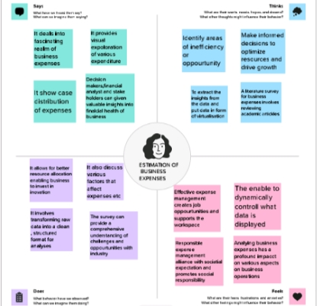

**Brainstorming Map**

Ideation is the process of forming ideas from conception to implementation, most often in a business setting. Ideation is expressed via graphical, written, or verbal methods, and arises from past or present knowledge, influences, opinions, experiences, and personal convictions. Brainstorming is a group problem-solving method that involves the spontaneous contribution of creative ideas and solutions. This technique requires intensive, freewheeling discussion in which every member of the group is encouraged to think aloud and suggest as many ideas as possible based on their diverse knowledge. Brainstorming combines an informal approach to problem-solving with lateral thinking, which is a method for developing new concepts to solve problems by looking at them in innovative ways. Some of these ideas can be built into original, creative solutions to a problem, while others can generate additional ideas. Common methods of brainstorming include mind mapping, which involves creating a diagram with a goal or key concept in the centre with branches showing subtopics and related ideas; writing down the steps need to get from Point A to Point B; "teleporting" yourself to a different time and place; putting yourself in other people’s shoes to imagine how they might solve a problem; and "super storming," or using a hypothetical superpower such as X-ray vision to solve a problem.

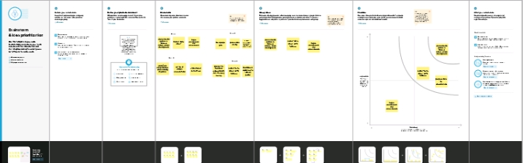

### Business Requirements

### The primary business requirements for this report are to visualize and analyze business expenses, provide industry-specific insights, identify cost drivers, highlight outliers, and offer interactive functionality. Stakeholders need a visual representation of expenses to compare and analyze spending patterns across different businesses and industries. The report should facilitate the identification of key cost drivers, enabling stakeholders to understand the primary factors contributing to expenses. Additionally, it should flag any outliers or anomalies for further investigation

**Data Preparation**

Data preparation, also known as data pre-processing, is a crucial step in the data analysis process. It involves transforming raw data into a clean, structured, and suitable format for analysis. Proper data preparation ensures that the data is accurate, consistent, and ready to be used effectively to derive meaningful insights.

**Data Visualization**

Data visualization is the process of creating graphical representations of data in order to help people understand and explore the information. The goal of data visualization is to make complex data sets more accessible, intuitive, and easier to interpret. By using visual elements such as charts, graphs, and maps, data visualizations can help people quickly identify patterns, trends, and outliers in the data.

### No of Unique Visualizations

The number of unique visualizations that can be created with a given dataset. Some common types of visualizations that can be used to analyze the performance and efficiency of a project include bar charts, line charts, heat maps, scatter plots, pie charts, Maps, etc. These visualizations can be used to compare performance, track changes over time, and show distribution, and relationships between variables.

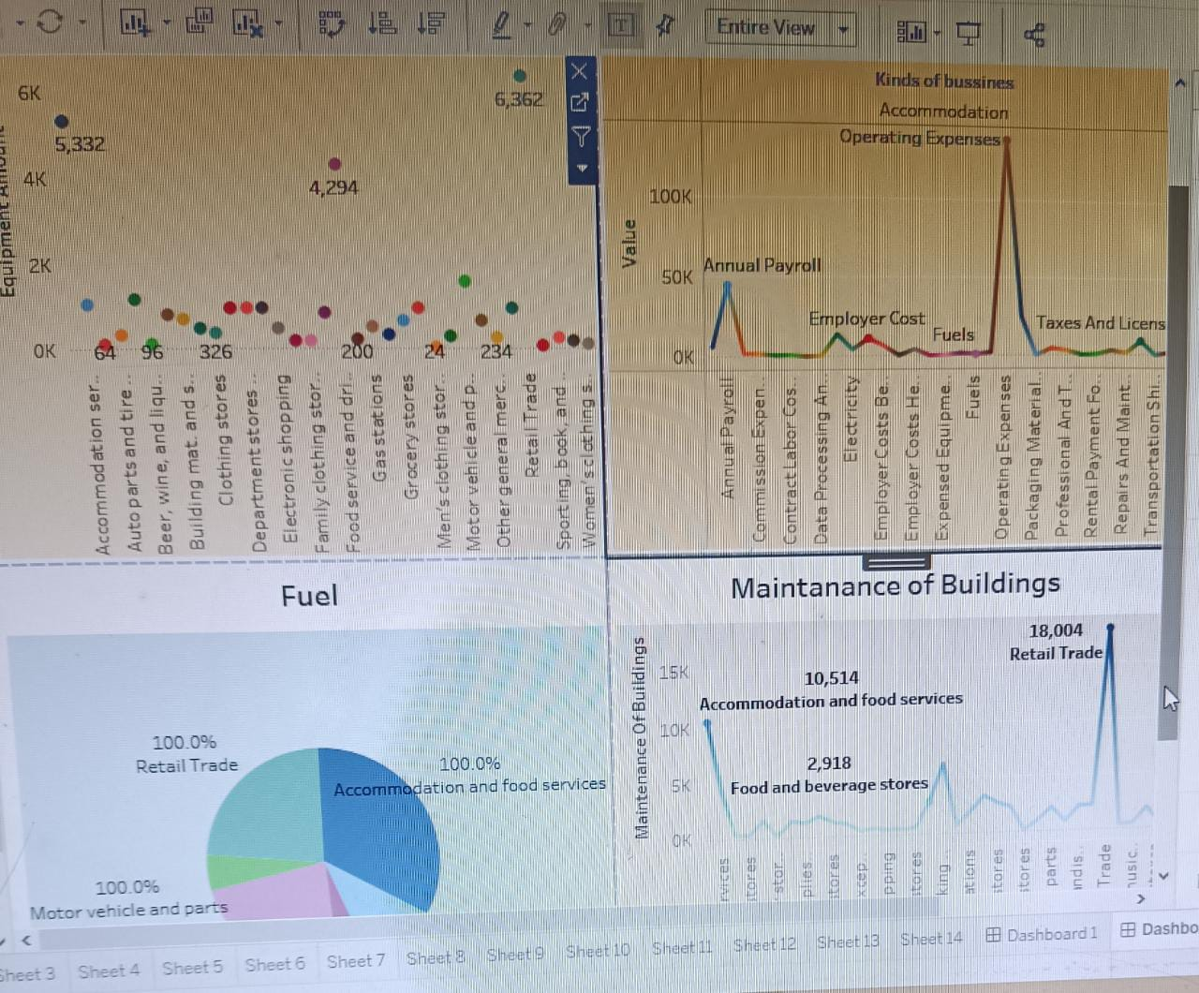

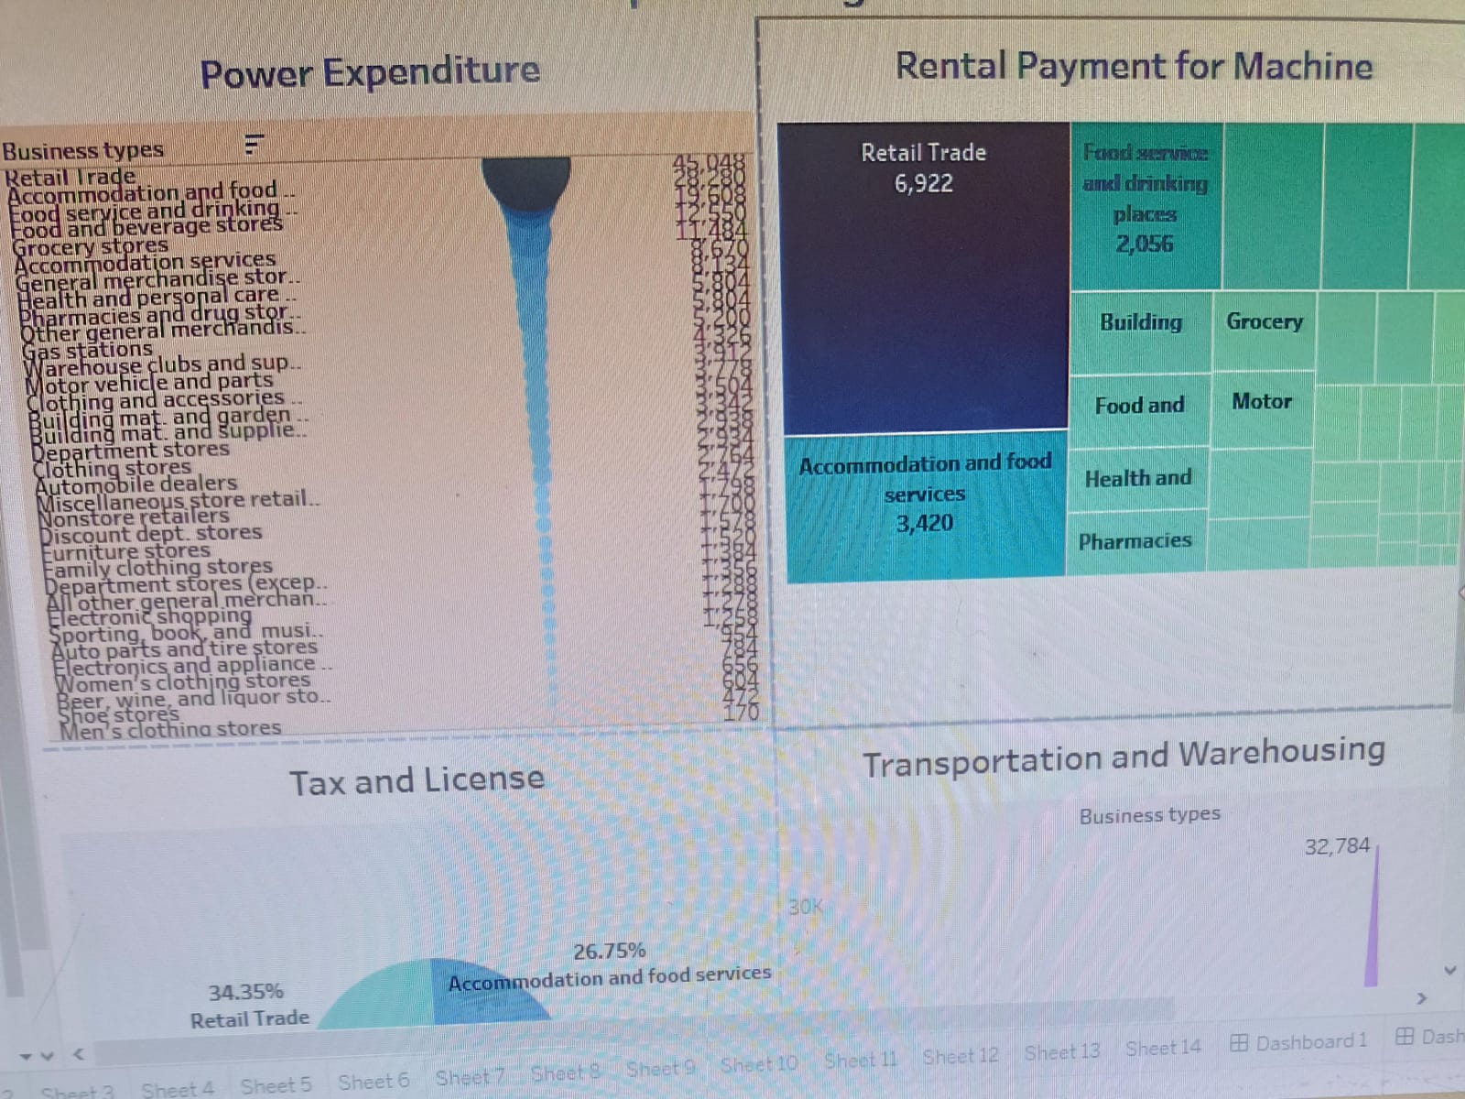

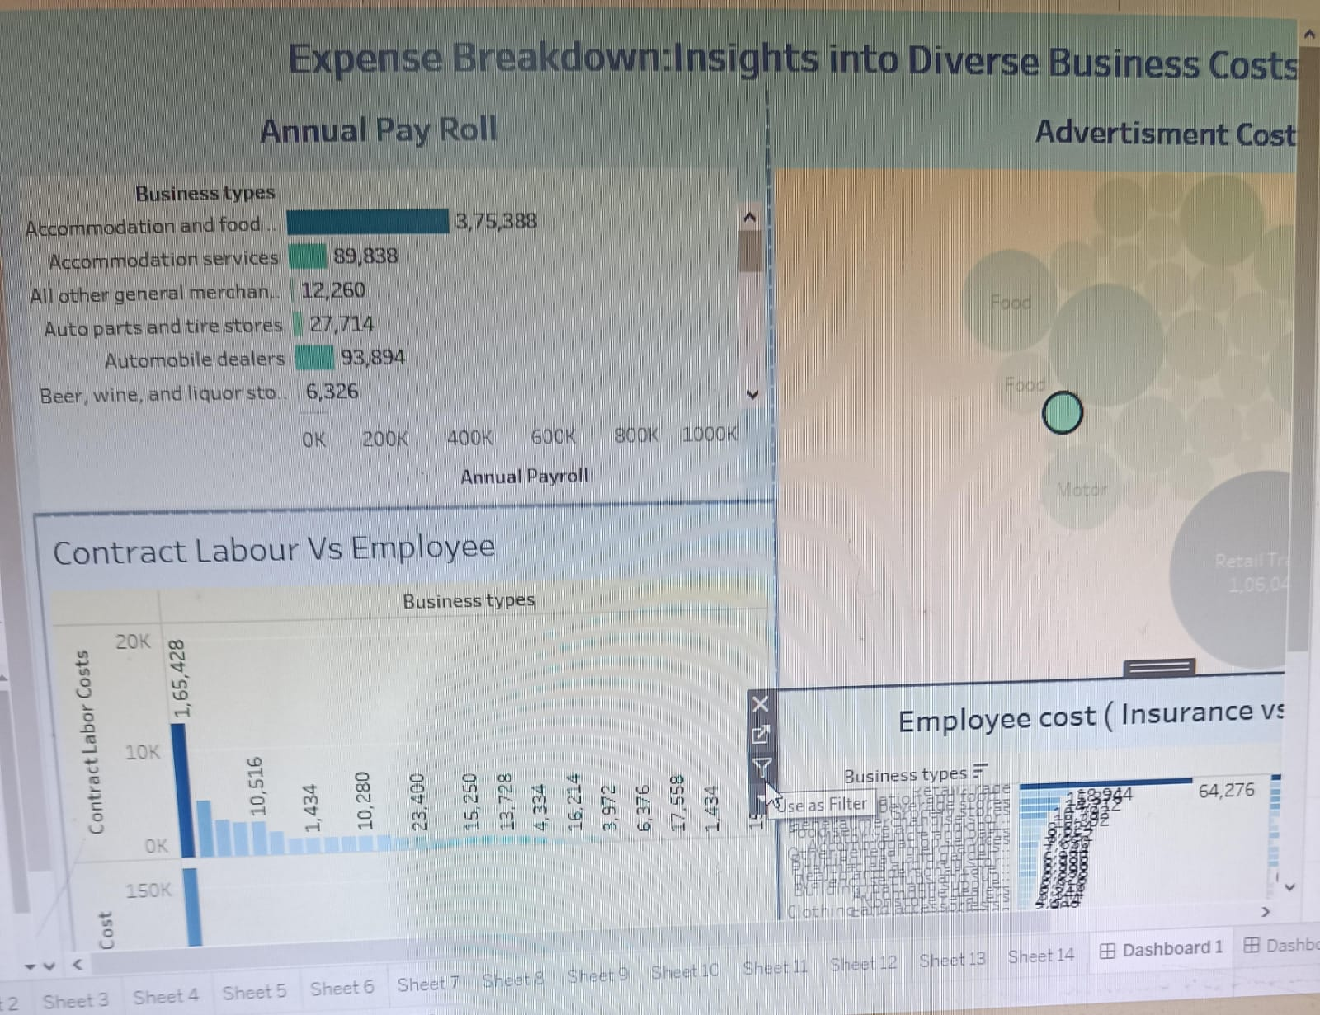

OUTPUT:

* The annual payroll is greater for retail trade(Rs.7,89,914.00) and less for men’s clothing stores (Rs.26,714.00/-)
* Power expenditure, Tax and license, Rental payment, Advertisement cost, Annual Pay Roll, Contract Labour vs. Employee, Expense YoY, Fuel, Transportation, Equipment cost can be calculated.

ADVANTAGES

* *Accurate estimation for businesses*
* *More accurte planning*
* *Improves profit*
* *Build strong relation in client*

DISADVANTAGE

APPLICATION

Effort estimation is one of the most important tasks in project management. The basic success of a project depends on it. At the same time, it can be used to determine the profitability of the project before expenses are incurred or resources are consumed. There are different methods for this, such as the top-down or bottom-up method.

Tasks of effort estimation

Effort estimation fulfils two tasks. On the one hand, it can be used as a decision criterion to assess whether a project can be carried out economically. Secondly, it can be compared with the current effort recording during the course of the project. By comparing estimated and recorded expenditure, it is possible to assess whether or not the project is within the estimated cost framework at the time of the survey.

CONCLUSION:

A business plan is a formal document that describes a new or existing company's goals and how the organization intends to reach them. Each business plan includes a conclusion that outlines its key points and the company's strengths. An effective business plan conclusion will convince the read. A business plan is a formal document that describes a new or existing company's goals and how the organization intends to reach them. Each business plan includes a conclusion that outlines its key points and the company's strengths. An effective business plan conclusion will convince the reader that the business is going to be successful.

DOCUMENTATION BY

1. ARIYA M U
2. ASHIKA R
3. JENIFER C S
4. PRIYADHARSHINI P S